**PLOT MAP**

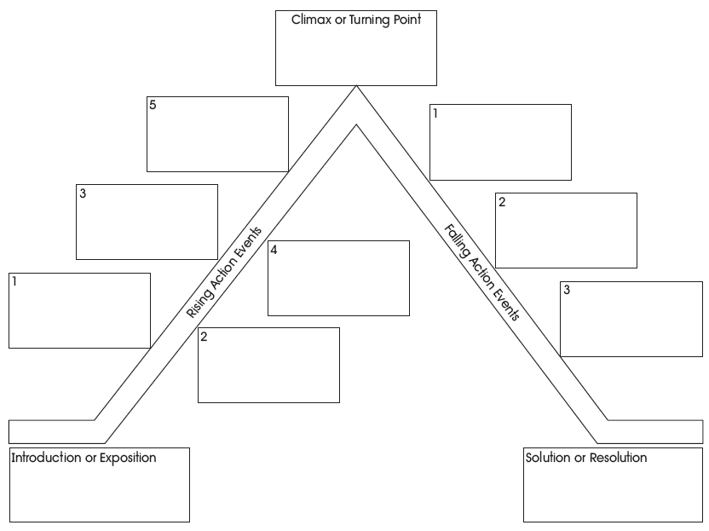

Write at least two sentences for each box. Attach this to your story analysis.